R Assignment

G.DIVIJA (18HP1A1207)

IT

(1Q)Create a graph with 2 vectors and include 10 points each.

Ans. >x<-seq(0,9,2.0)

>y<-seq(0,9,2.0)

>plot(x,y)

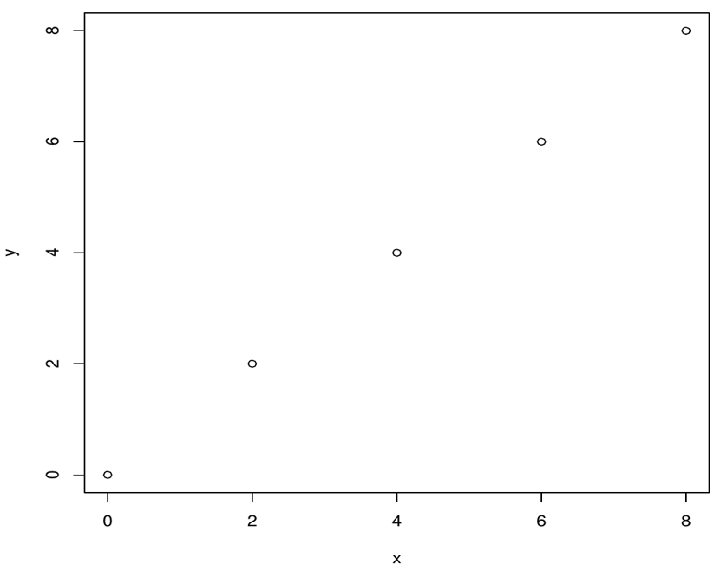

>x<-seq(0,9,2.0)

>y<-seq(0,9,2.0)

>plot(x,y)

>lmount<-lm(y~x)

>abline(lmount)

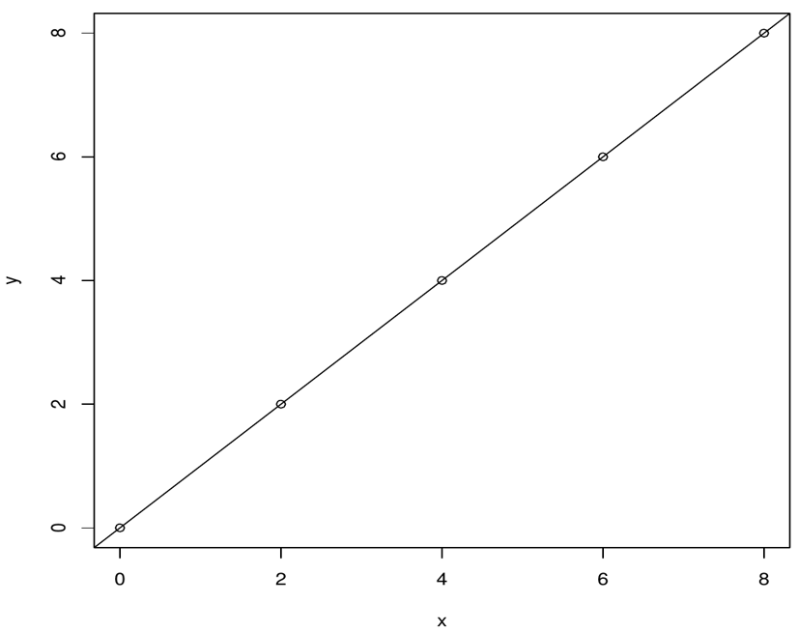

(2Q) Explain about probability distribution and execute normal

distribution in r.

Ans: Probability Distribution: The binomial distribution model deals with finding the probability of

success of an event which has only two possible outcomes in a series of experiments. For example,

tossing of a coin always gives a head or a tail. The probability of finding exactly 3 heads in tossing a

coin repeatedly for 10 times is estimated during the binomial distribution.

A probability distribution describes how the values of a random variable is distributed. ex: The

collection of all possible outcomes of a sequence of coin tossing is known to follow the binomial

distribution. Where as the means of sufficiently large samples of data population are known to

resemble the normal distribution.

Normal Distribution: The normal distribution is defined by the following

probability density function ,where μ is the population mean and σ2 is

the variance.f(x)=1/(σ√2π )e^-(x-μ)2/2σ2

μ=0 and σ=1 is called standard normal distribution and is denoted as N(0,1).

It can be graphed as follows:

R has four in built functions to generate normal distribution. They are

described below.

dnorm(x, mean, sd)

pnorm(x, mean, sd)

qnorm(p, mean, sd)

rnorm(n, mean, sd)

Following is the description of the parameters used in above functions −

x is a vector of numbers.

p is a vector of probabilities.

n is number of observations(sample size).

mean is the mean value of the sample data. It&#39;s default value is zero.

sd is the standard deviation. It&#39;s default value is 1.

dnorm():

This function gives height of the probability distribution at each point

for a given mean and standard deviation.

>x <- seq(-10, 10, by = 0.2)# Create a sequence of numbers between -10

and 10 incrementing by 0.1.

>y <- dnorm(x, mean = 1.2, sd = 0.4)# Choose the mean as 2.5 and

standard deviation as 0.5.

>plot(x,y)

GRAPH:

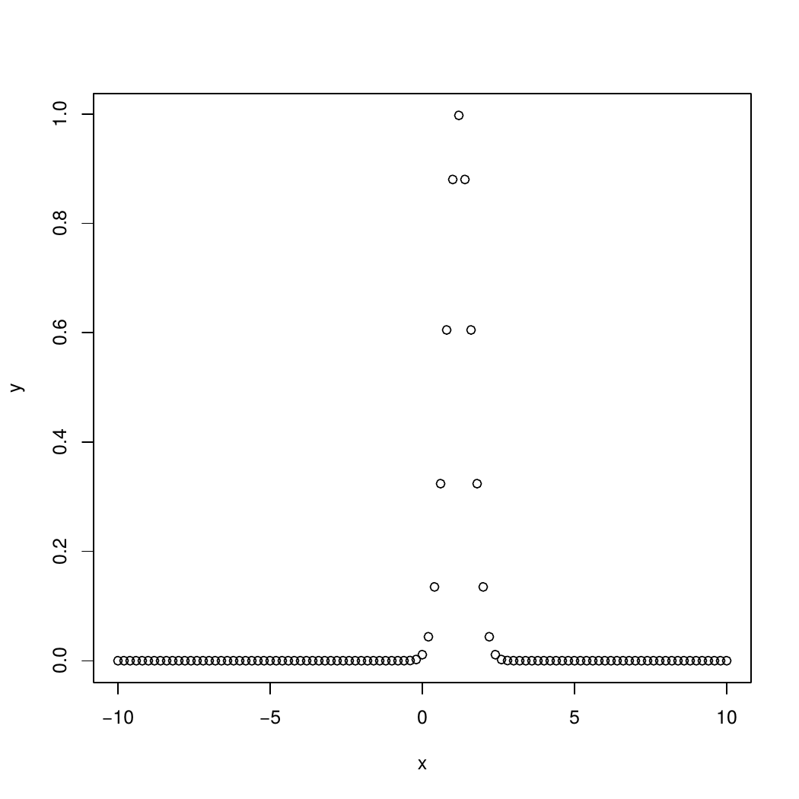

pnorm():

This function gives the probability of a normally distributed random

number to be less that the value of a given number. It is also called

&quot;Cumulative Distribution Function&quot;.

>x<- seq(-4,6,by = 0.3)

>y<- pnorm(x, mean = 2.8, sd = 3)

>plot(x,y)

GRAPH:

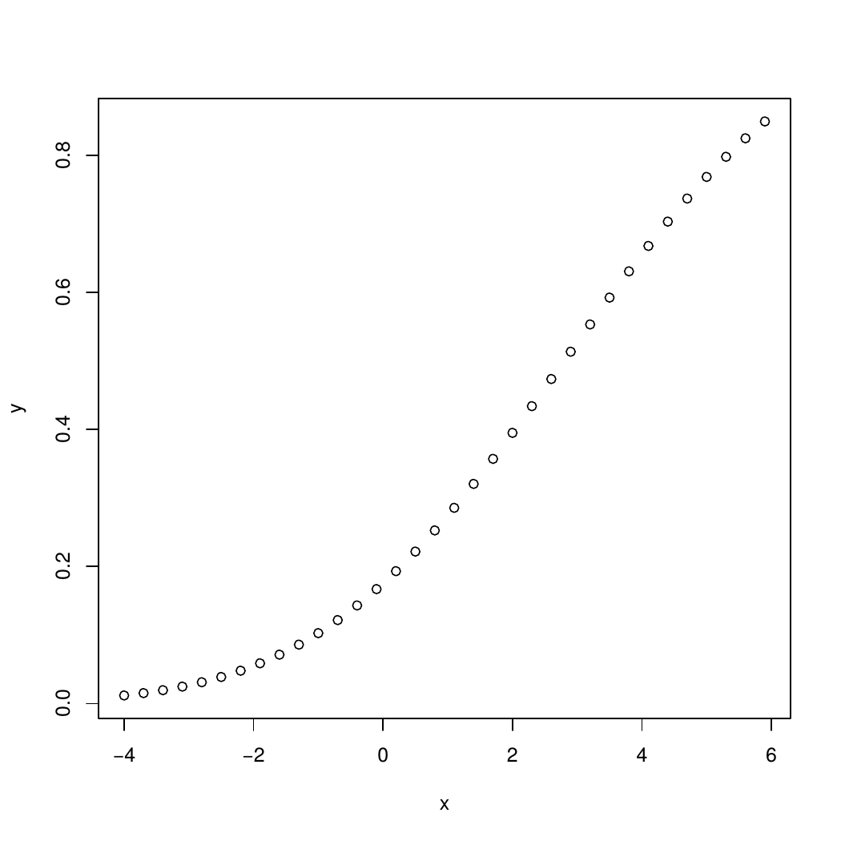

qnorm():

This function takes

the probability value and gives a number whose cumulative value matches the

probability value.

>x<- seq(0, 1, by = 0.01)

>y<- qnorm(x, mean = 3, sd = 2)

>plot(x,y)

GRAPH:

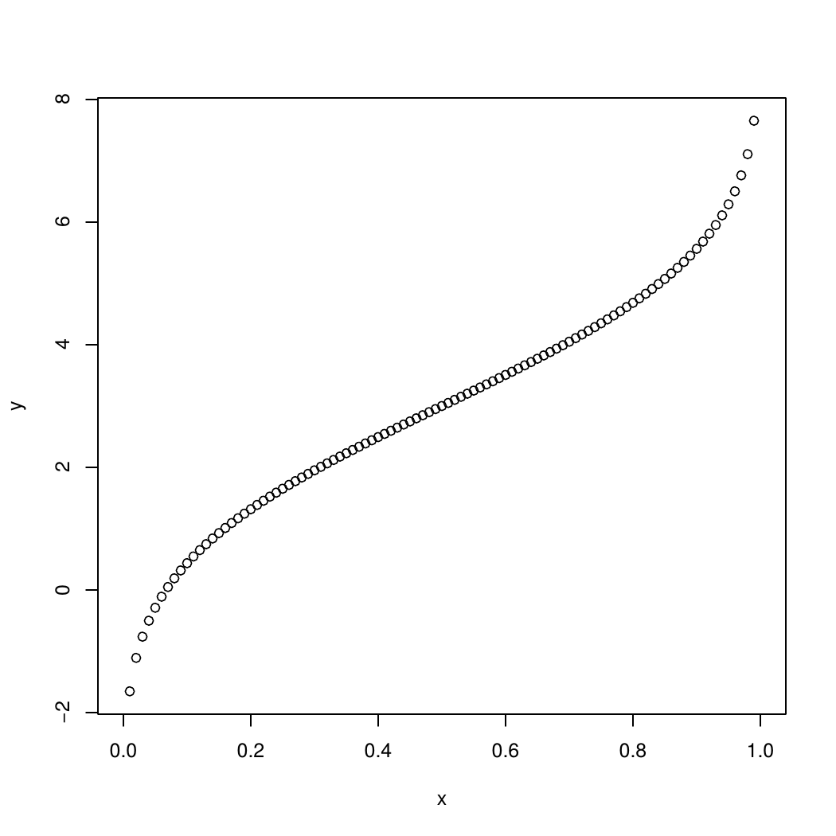

rnorm():

This function is used to generate random numbers whose distribution is normal.

It takes the sample size as input and generates that many random numbers. We

draw a histogram to show the distribution of the generated numbers.

>y<- rnorm(30) # Plot the histogram

hist(y, main = "Normal Distribution")

GRAPH:

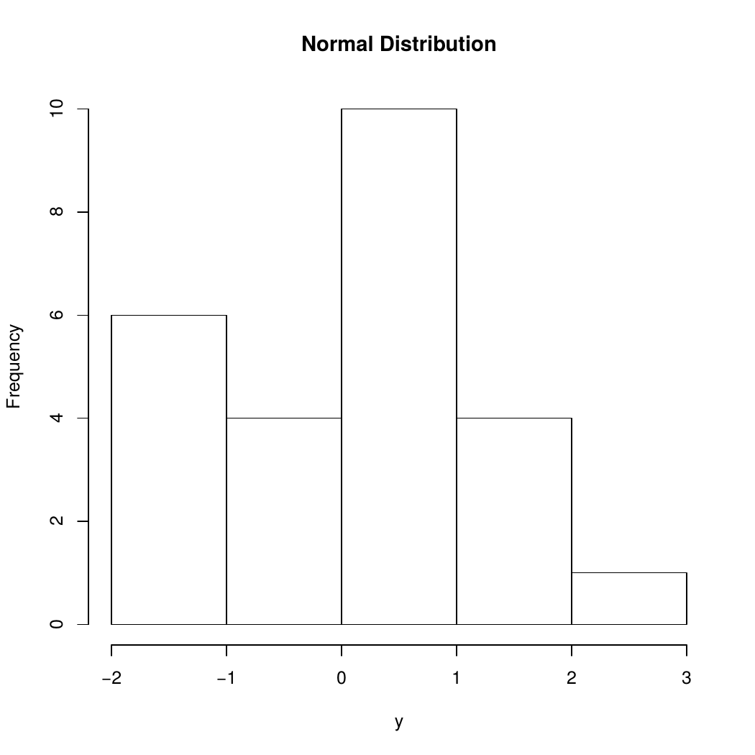

(3Q) Execute binomial distribution and create histograms with sizes of 1 each with n value 10.

Ans:

Binomial distribution:

Binomial distribution is a discrete probability. It describes the

outcome of n independent trails in an experiment.

“R has four in-built functions to generate binomial distribution. They

are described below”

dbinom(x, size, prob)

pbinom(x, size, prob)

qbinom(p, size, prob)

rbinom(n, size, prob)

Following is the description of the parameters used −

x is a vector of numbers.

p is a vector of probabilities.

n is number of observations.

size is the number of trials.

prob is the probability of success of each trial.

dbinom():

This function gives the probability density distribution at each point.

Create a sample of 30 numbers which are incremented by 2.

>x<- seq(0,30,by = 2)

# Create the binomial distribution.

>y<- dbinom(x,30,0.3)

# Plot the graph for this sample.

>plot(x,y)

GRAPH:

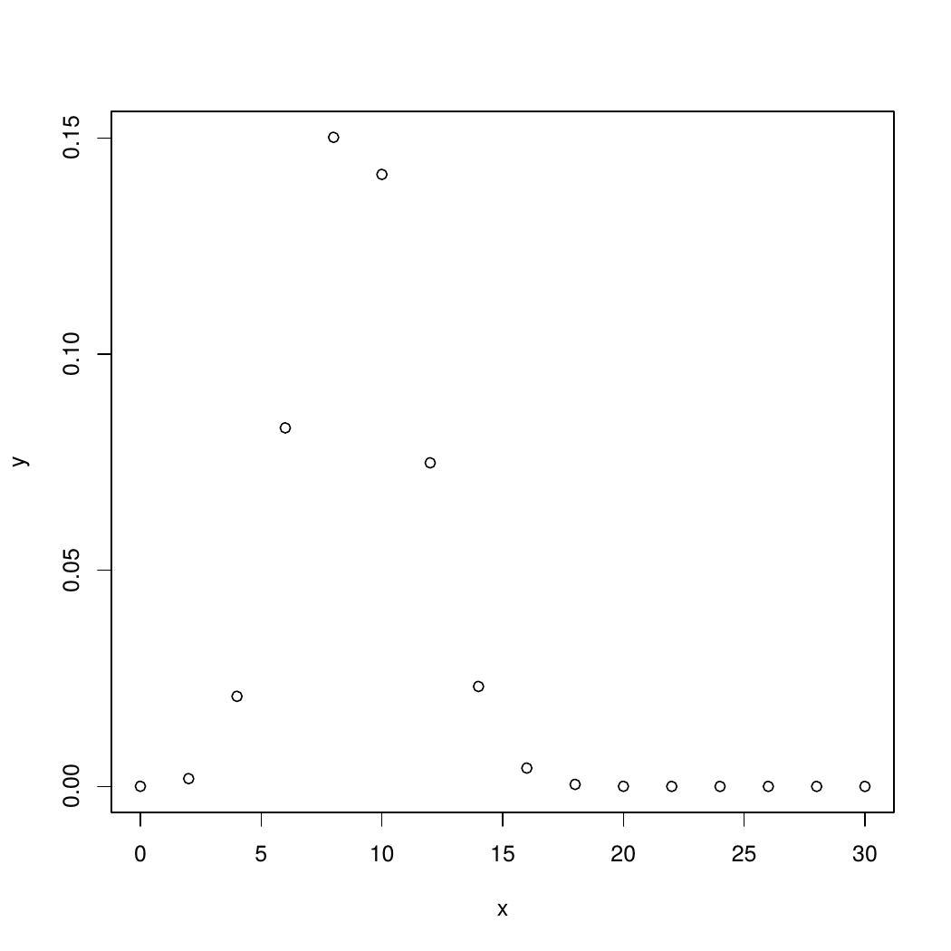

pbinom():

This function gives the cumulative probability of an event. It is a single

value representing the probability.

# Probability of getting 11 or less heads from 31 tosses of a coin.

>x <- pbinom(11,31,0.3)

>print(x)

EXAMPLE:

[1] 0.8075859

>x <- pbinom(21,51,0.4)

>print(x)

OUTPUT:

[1] 0.626497

qbinom():

This function takes the probability value and gives a number

whose cumulative value matches the probability value.

EXAMPLE:

>x <- qbinom(0.20,30,2/3)

>print(x)

OUTPUT:

[1] 18

rbinom():

This function generates required number of random values of given

probability from a given sample.

EXAMPLE:

>x <- rbinom(25,150,0.25)

>print(x)

OUTPUT:

[1] 29 40 32 34 39 39 36 42 39 37 48 35 42 30 44 34 33 32 29 36 44 38 40 33 40

PLOTTING HISTOGRAMS:

>x=c(0,1,2,3,4,5,6,7,8,9)

>hist(x,prob=0.9,n=10)

HISTOGRAM:

# C:\Users\divij\AppData\Local\Packages\Microsoft.Office.Desktop_8wekyb3d8bbwe\AC\INetCache\Content.MSO\7D82AEF2.tmp

DONE BY:

G.DIVIJA

(18HP1A1207)